NULL IF FUNCTION:

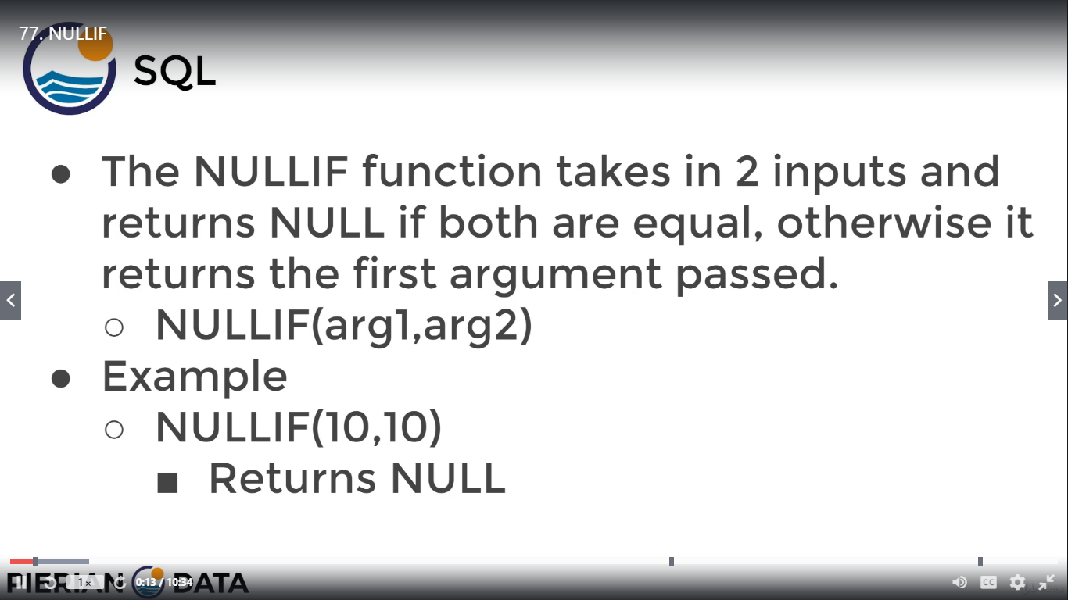

IN this query we are trying to show that instead of showing zero how this query will show null value by using NULL IF condition

First creating a new table



Now insert values into this table

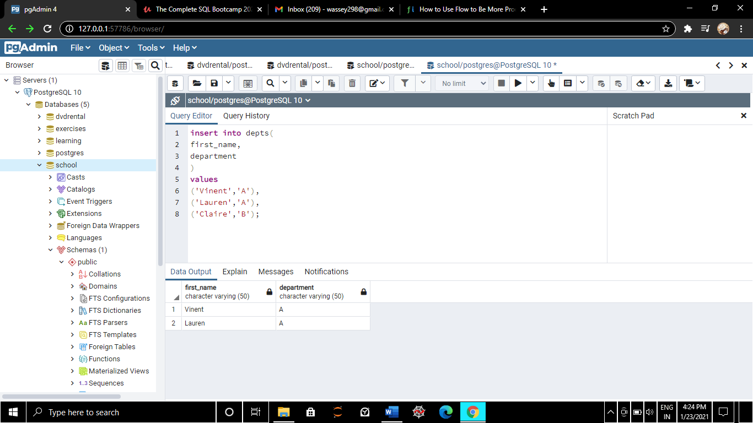

Here using CAST condition which gives output as 2

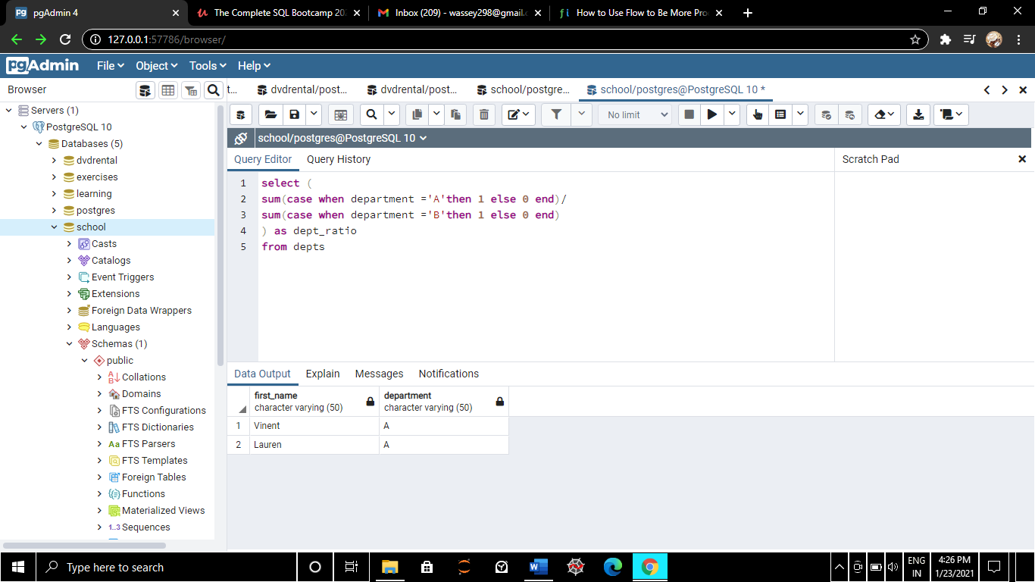

Here we are deleting department B

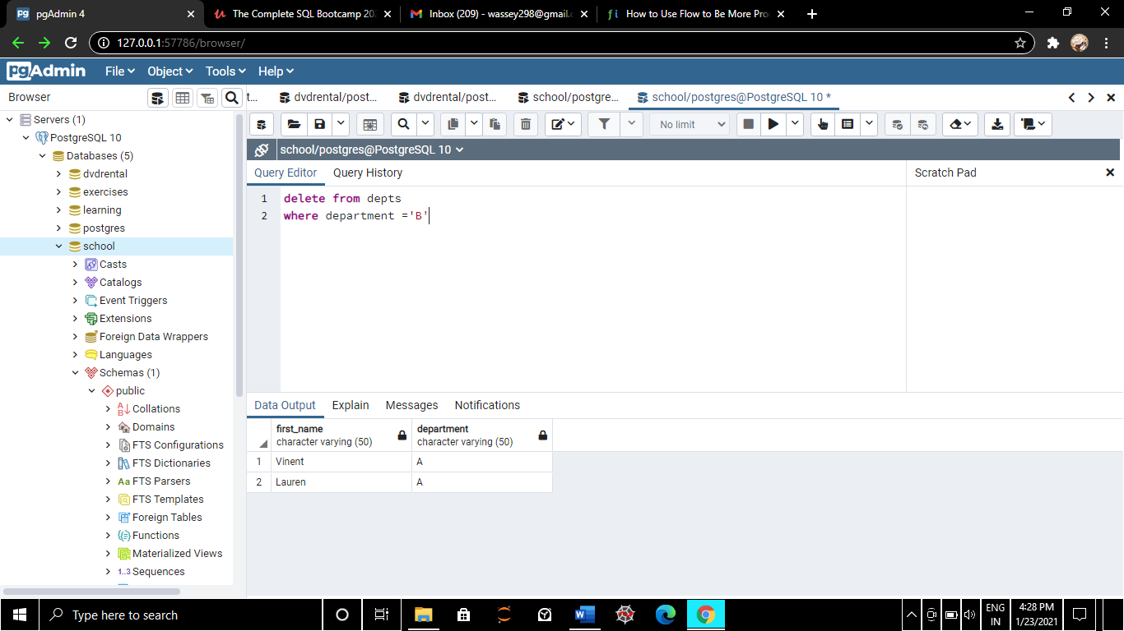

After deleting B if we again execute CAST condition it will give error division by zero

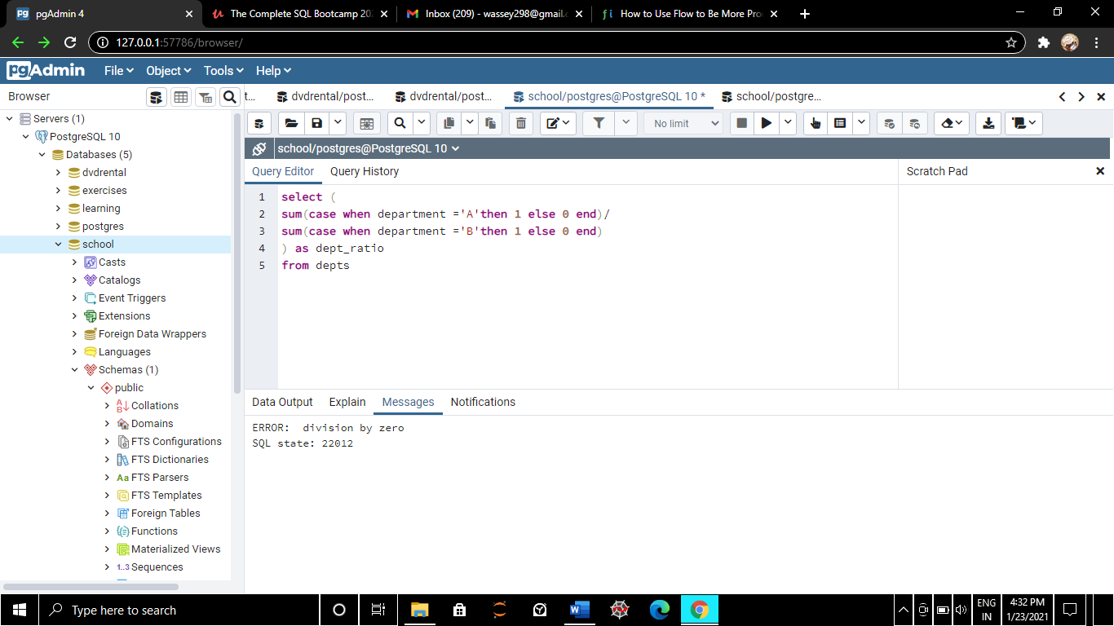

Now executing NULL IF in cast condition given below it will give null value

